ISO Settings in Digital Photography
Grant (a reader of DPS) asks – ‘I’m confused about ISO. What is the best setting to choose? Should I always choose the lowest one?’
Thanks for the question Grant. Before I attempt to answer it let me give a quick definition of ISO:

What is ISO?
In traditional (film) photography ISO (or ASA) was the indication of how sensitive a film was to light. It was measured in numbers (you’ve probably seen them on films – 100, 200, 400, 800 etc). The lower the number the lower the sensitivity of the film and the finer the grain in the shots you’re taking.
In Digital Photography ISO measures the sensitivity of the image sensor. The same principles apply as in film photography – the lower the number the less sensitive your camera is to light and the finer the grain. Higher ISO settings are generally used in darker situations to get faster shutter speeds (for example an indoor sports event when you want to freeze the action in lower light) – however the cost is noisier shots. I’ll illustrate this below with two elargements of shots that I just took – the one on the left is taken at 100 ISO and the one of the right at 3200 ISO (click to enlarge to see the full effect).
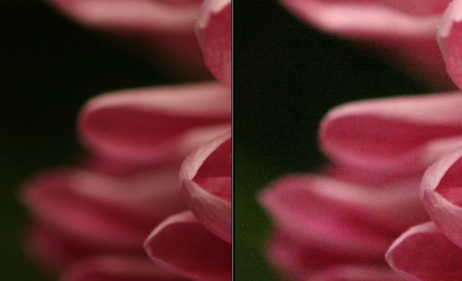
(you can see larger sized images of both shots here for the 100 ISO and here for the 3200 ISO)

100 ISO is generally accepted as ‘normal’ and will give you lovely crisp shots (little noise/grain).
Most people tend to keep their digital cameras in ‘Auto Mode’ where the camera selects the appropriate ISO setting depending upon the conditions you’re shooting in (it will try to keep it as low as possible) but most cameras also give you the opportunity to select your own ISO also.
When you do override your camera and choose a specific ISO you’ll notice that it impacts the aperture and shutter speed needed for a well exposed shot. For example – if you bumped your ISO up from 100 to 400 you’ll notice that you can shoot at higher shutter speeds and/or smaller apertures.
When choosing the ISO setting I generally ask myself the following four questions:
- Light – Is the subject well lit?
- Grain – Do I want a grainy shot or one without noise?
- Tripod – Am I using a tripod?
- Moving Subject – Is my subject moving or stationary?
If there is plenty of light, I want little grain, I’m using a tripod and my subject is stationary I will generally use a pretty low ISO rating.
However if it’s dark, I purposely want grain, I don’t have a tripod and/or my subject is moving I might consider increasing the ISO as it will enable me to shoot with a faster shutter speed and still expose the shot well.
Of course the trade off of this increase in ISO will be noisier shots.
Situations where you might need to push ISO to higher settings include:
- Indoor Sports Events – where your subject is moving fast yet you may have limited light available.
- Concerts – also low in light and often ‘no-flash’ zones
- Art Galleries, Churches etc- many galleries have rules against using a flash and of course being indoors are not well lit.
- Birthday Parties – blowing out the candles in a dark room can give you a nice moody shot which would be ruined by a bright flash. Increasing the ISO can help capture the scene.
ISO is an important aspect of digital photography to have an understanding of if you want to gain more control of your digital camera. Experiment with different settings and how they impact your images today.
Read more: http://digital-photography-school.com/iso-settings#ixzz2dHVpa4qi

