Taking Multiplicity Photographs

Instructions
1. As for the subject you can really use anything you like, I've used flowers, lens cap, logos, and even candy.
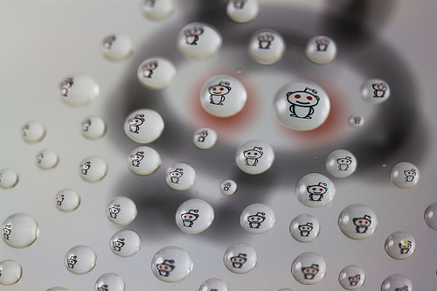
2. Take piece of glass and apply the RainX. Once you have done that place you glass on the two boxes, try to get the boxes on the very edge of the glass, gives you more working room with the water beads.
3. Place you subject under the glass, you're gonna have to flip it, so that the reflection in the water beads are the correct way. (of flip your camera, or god forbid flip in post :) You will have to move your subject around until you have it centered in you water beads.
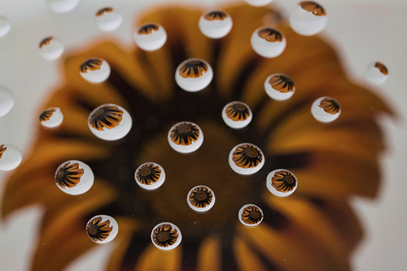
4. As far as focusing goes, it is best to use manual focus so the focus grid does not get confused. Make sure you focus on the images inside the water beads. If you have live view I recommend using it, and zooming in to makes focusing a lot easier.
5. If you want a good sharp picture, consider placing your object on a white surface and using a strobe to light it.
6. Snap your shot
7. You can play with the aperture to gain different depth of field images.
