Screenplay Formatting
by Derek Beck Staff Apr 7, 2011
While there is no official "correct" way to format or write a script, having a formatted screenplay can really do wonders for your overall production! It can turn a disorganized group of actors, videographers, and directors into an efficient team of filmmakers. Screenplays help project your vision into the eyes of your entire film crew! Word, ya heard? After all, there comes a time when every writer/filmmaker should transition their film script from this:
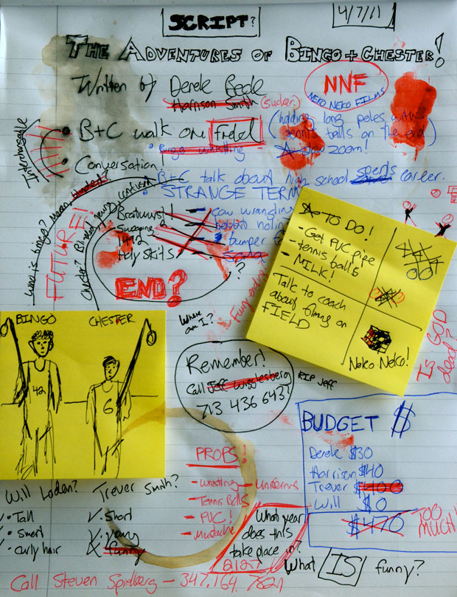
To this!
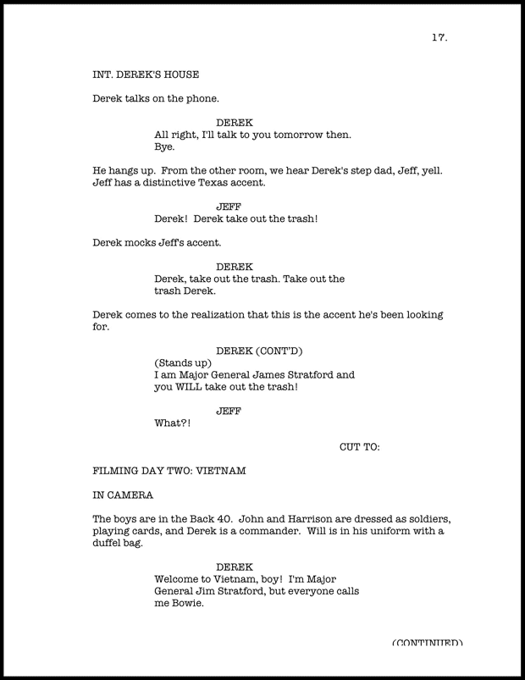
Screenwriting is basically comprised of four simple components: Stage direction and shot headings (or Slug Lines), Action, Character names, and Dialogue.
Slug Lines help establish scene and setting. At the beginning of each new scene there should always be a quick slug line. They usually look something like this:
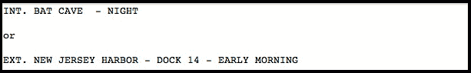
INT. and EXT. stand for Interior and Exterior. They provide the reader with a setting for the scene. Interior meaning the scene takes place inside, exterior meaning outside. Typically a hyphen (or dash) separates location from time of day. Sluglines are typically typed across the page from left margin to right margin in ALL CAPS.
Action is used to describe what the audience will be experiencing on the screen.
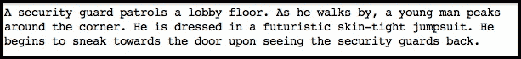
Action is always written in present tense and follows standard rules of grammar. Some screenwriters choose to include camera direction within their screenplay. (i.e. As he walks by, we pan over to see a young man peaking around the corner.) We do not recommend to add direction in your screenplay, this can be left for the director.
Sounds are typically capitalized to emphasize the noise behind the action. For example, the bus SCREECHED to a stop. (Add more E's if needed!)
Character Names are introduced within the action. When introducing a character, always capitalize their NAME. This rule doesn't just apply to the main characters. If you are introducing a BODYGUARD or MAGICIAN, the same rules apply!
Dialogue is the words that the characters speak. Simple enough!
It is important to remember that screenplay dialogue uses no quotations and it is usually centered and starts under the characters name. Also, if you want to add detail of what the character looks like or how he delivers the line, just add it in parenthesis below the characters name, like so:
Here is a example using all of the techniques we have gone over:
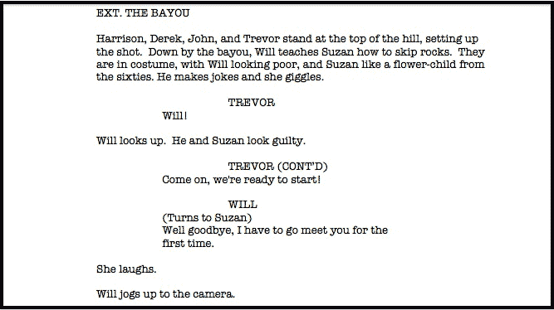
One final detail, your screenplay should be written on standard 8.5 x 11 inch paper. Always use Courier font, 12 point. (OR ELSE...)
You'll find that presenting your thoughts following these simple conventions will help to more clearly convey your ideas to your cast and crew which will make your production go more smoothly. That sounds like a good thing, right? Now you're all set.
Go write your screenplay!

