News Event Collage
Photoshop Assignment

- Create an 8x10 canvas, 300 Resolution.
- Use only pictures that are at least 1000 pixels H or W. Only search large images on Google, by clicking on “tools” and then “size”.
- Find 10-12 images that are relevant to a social or news event that happened in the last six months or is an ongoing news story.
- Use the eraser tool or anything else you can find in Photoshop to soften the edges.
- Place a title text, with an appropriate font choice, in the canvas with the name of the event.
- Consider placing a semi-opaque image over the top of, or behind, your smaller images.
- Be aware of all horizontal and vertical
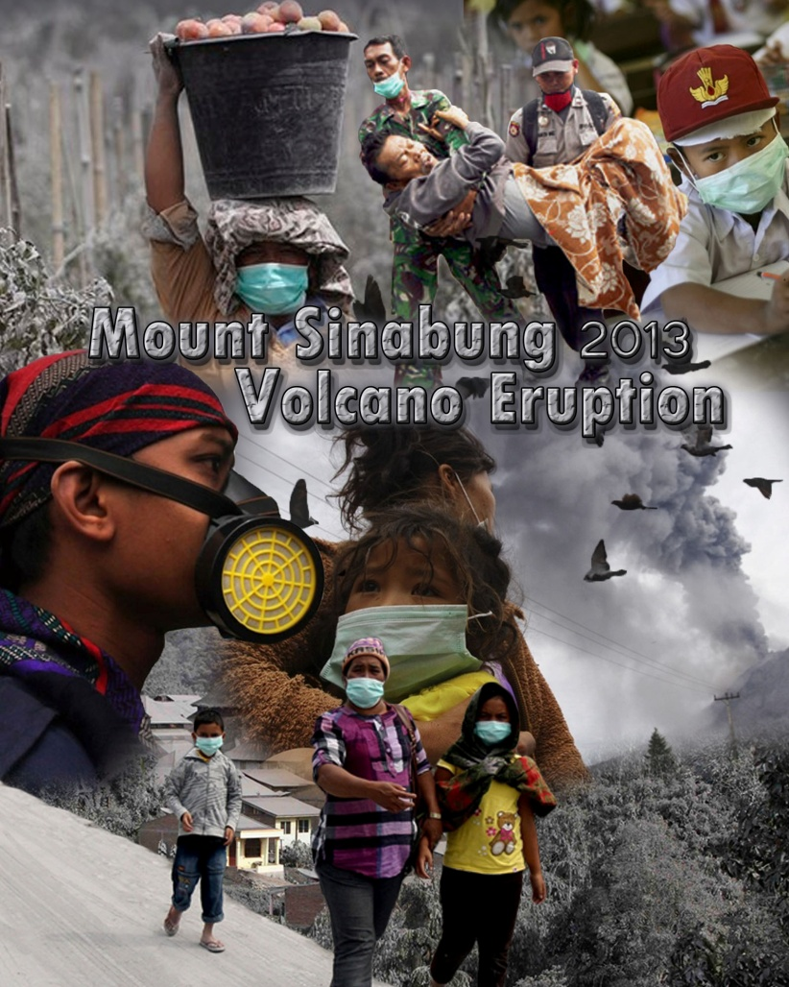
lines as they can be distracting. The goal
is to create an entirely new image using
parts of existing images, not to just
present a collection of existing images.
8. Turn in to drop of folder for grading.

