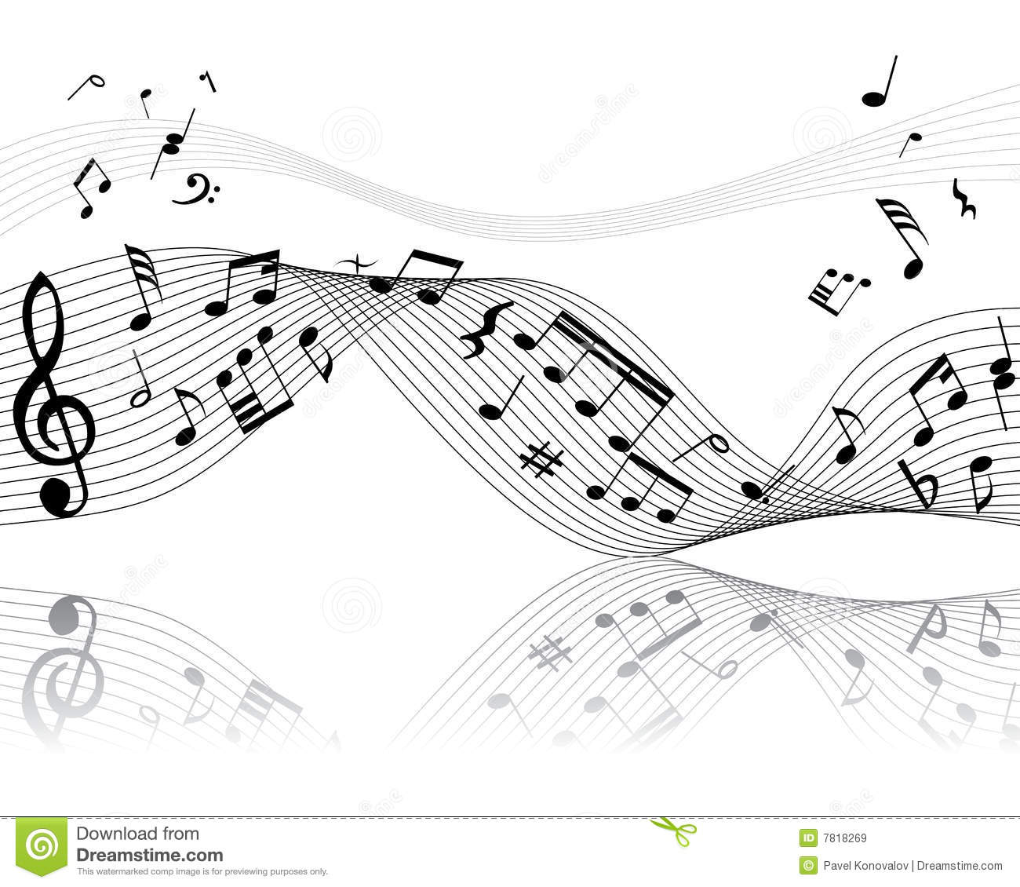
“Music” Assignment

Create FOUR high quality and interesting images of people with instruments AND just instruments alone utilizing the following:

Two images must be of both the instrument AND the musician. You do not need to show the entire person in the shot, in fact, it is more interesting to see how little of the person you can keep in the shot and still maintain the meaning of the picture. Keep the shot close. Fill the frame.
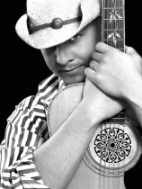
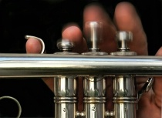
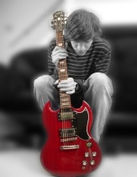

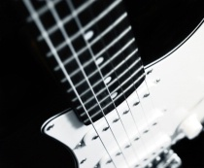
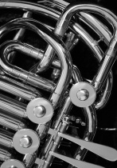
Two images must be of the instrument alone. Simple background! The lighting is very important. Perhaps start with a dark room and then stage 1-2 lights that best show off the instrument. Need to photograph the entire instrument? Probably not. Show the viewer a detail that they have never observed before. Choose an interesting angle? Composition? Simplicity?

