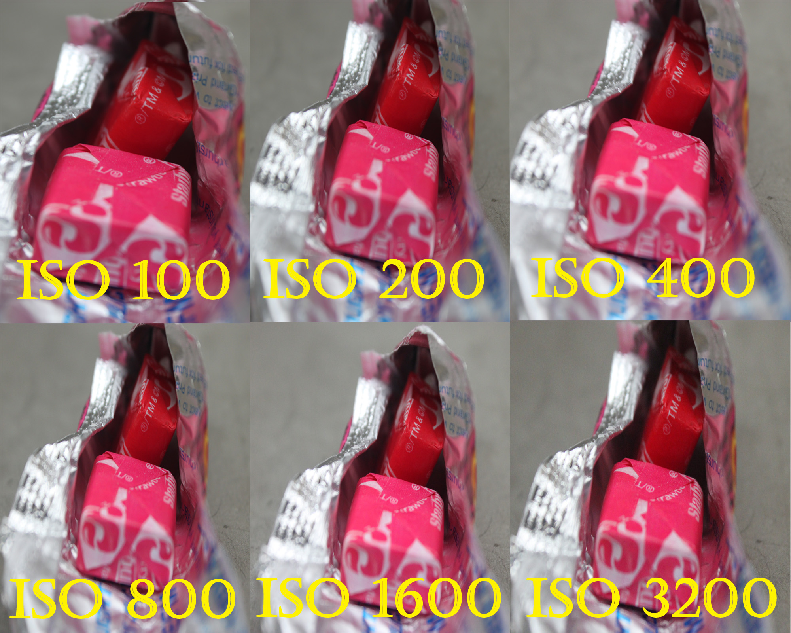Photo Assignment
ISO Exposure

Find an Area where is not too dark or too bright.
Set the camera on a tripod and take the same
picture with out changing views.
Change the ISO 6 Times.

Directions

- Use AV Settings
- Shoot your object using a Tripod
- Stay Indoors
- Photograph an object 10-15 inches from the camera
- Focus on the object
- Use a 55mm lens (Focal Length)
- Take 6 pictures:

- Smallest ISO (probably 100 ISO)
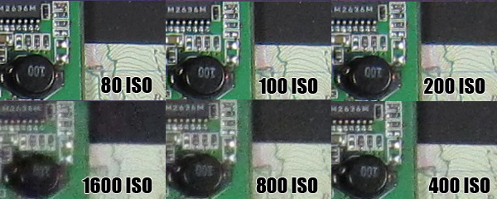
- 200 ISO
- 400 ISO
- 800 ISO
- 1600 ISO
- Largest ISO

B) Open Photoshop to create your ISO Composition
Make the canvas 9” wide by 6” tall at 200dpi
Each Picture should be 3x3 and labeled with the ISO
