Depth of Field Exercise

Place five markers (an Object) at Four foot intervals and slightly staggered so that you can see all of the markings when sighted down. Get close to the first object and focus on the third one. (The Object right in the Middle)

Use only a camera that has a “Manual” setting available and create a good exposure utilizing the highest available “F” Stop (probably f22 on the Cannon T1i) while sighting down all of the markers. Then adjust the F-stop 2 stops lower, adjust the shutter speed to compensate for the exposure and expose again. Repeat this process until you reach the lowest F-stop (probably f3.5).

**Shallow Depth of Field**

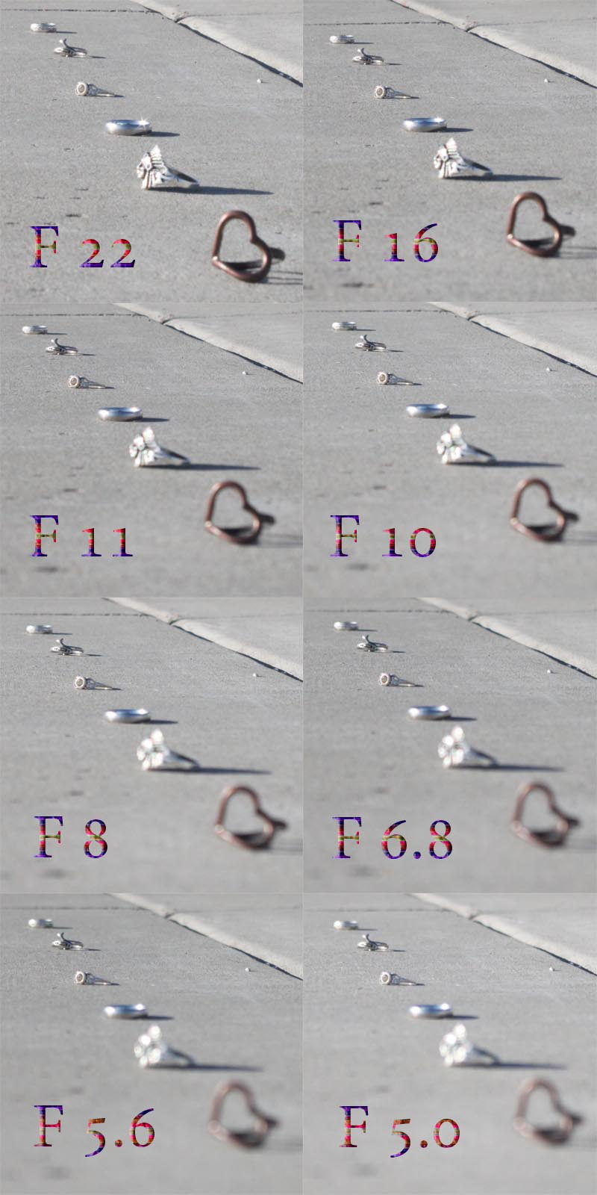



Create a canvas that will fit all of your pictures,

with a maximum size of 11” wide by 18” tall.

Arrange all of your pictures on the canvas so they

are in the order taken and the F-Stop is listed on

each photo and easy for anybody to understand

and comprehend.