Battery Basics
by Mark Staff Aug 5, 2011
Batteries power almost all our gadgets nowadays, and cameras are no exception. When it comes to production, it can be difficult keeping track of all the different battery options, but with a little research, you can find the best solution for your equipment.
In preparation for this lesson, we made this video. Unfortunately we had some technical difficulties.
No big deal though! It's a fairly straightforward topic so let's dig in!
Certain cameras still use non-rechargeable alkaline based batteries. While these batteries are generally cheaper, they don't last nearly as long and are only good for one time use. Fortunately, most modern cameras use rechargeable batteries.
Let's look at the two most common types of rechargeable batteries used in cameras. There's nickel metal hydride (NiMH), and lithium ion. Lithium ion is the preferred type for use in high end equipment as NiMH batteries tend to discharge when not in use and do not provide as much power overall. Because of this, most cameras are designed to use lithium ion batteries which are proprietary (meaning they are made for use in those specific cameras). Some lower end cameras use AA or AAA (NiMH) batteries since they're cheaper.
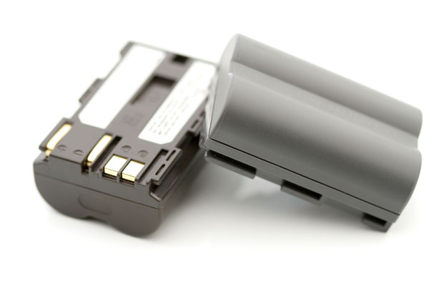
Here's an example of a typical lithium ion battery. Image courtesy of Shutterstock
Despite the advantages of lithium ion batteries, there are drawbacks. For one, they don't live forever. After about 500 cycles (draining followed by recharging) their performance degrades quite a bit and they require replacement. NiMH batteries can be even worse, needing replacement after even fewer charge cycles.
PPro tip: Recharging a partially drained NiMH battery can greatly reduce the life of your battery. Unlike NiMH batteries, lithium ion batteries don't need to be fully drained before recharging them!
Most of the time, when buying a battery, you have a choice of buying an expensive name brand or a cheaper 3rd party brand. Both batteries will generally provide equal performance, but be warned that some 3rd party batteries may have not be able to communicate with your camera, so your camera may not display information on how much power is left. Depending on your camera model, you may able to purchase an extended charge version. These will typically be larger than your normal battery but they will of course provide extended battery life.
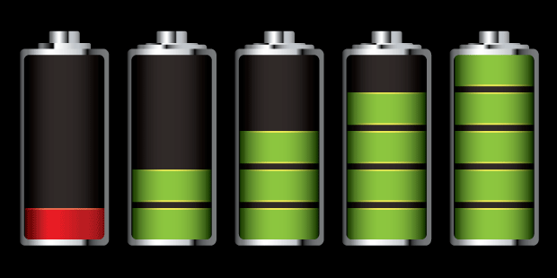
Most cameras will have some sort of icon, similar to the image above, to indicate the battery's charge level. Image courtesy of Shutterstock
What if you're on a shoot and running low on power? Well, that's a situation no one wants to be in, so if you feel like you're cutting it close, it's best to have a second battery fully charged and ready to go just in case your first battery dies. Optionally, if you're near a wall outlet, many cameras can be powered via an AC power adapter, so there's no need for a battery at all!
PPro tip: If you have two batteries, bring your charger with you on your shoot so if one drains, you can use your second battery and simultaneously charge the one that has been drained!
It's always a good idea to familiarize yourself with how long your battery lasts in your camera with a full charge under normal use. However, just like people, batteries work best at room temperature. Using your batteries in extreme temperatures can have a negative impact on your battery's life. That being said, the optimal operating temperature for Lithium ion batteries is 68°F, and you're good to go within a 20°F range of that. Anything higher or lower and you could experience drastically reduced battery life, so if you're planning on shooting in extreme temperatures, come prepared with more batteries, or have a way to keep your camera and other equipment in a relatively stable temperature area.
Keep in mind that there are lots of things your camera does that makes your battery drain faster. Using the LCD screen on your camera is a big one. Try looking into your camera settings and dimming your screen brightness, a lot of times it's set super bright by default. If you're looking to be more conservative, cut down on the use of external devices that use your cameras' battery (also known as phantom power, scary stuff). Things like camera lights, external LCD screens and microphones, can all drain your camera battery pretty quick. If you have the option, try buying an external device that has it's own power supply. Obviously, you can prolong your battery life by turning these things off (or even the camera itself) when not in use.
Once your battery has drained to the point where you're unable to use it, the proper way to dispose of it is to recycle! Check with your local, state, or federal environmental agency to find out the best way to do so.
Following these basic tips and general common sense should keep you and your batteries happy as can be, and help your shooting go smoothly. Now go out there and conserve some energy!

