6 Tips to Improve Your Panning Photography
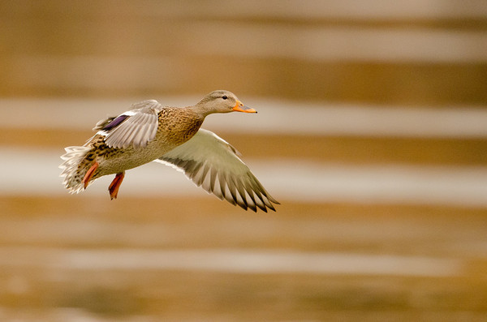
I took this photo in Idaho Falls, Idaho with a Nikon D7000 and a Nikon 600mm f/4 lens.
Whenever I see movement in a scene, I immediately ask myself whether I want to allow blur of the moving item to show movement, or if I want to freeze the action with a fast shutter speed. I personally believe that many photographers make the mistake of always freezing motion. It is certainly easy to freeze the motion in a scene with a fast shutter speed, but this technique can become a crutch if it is not used judiciously.
One of the most creative ways to show movement is to use a technique called panning. The image featured on this page is an example of panning. The bird is in sharp focus, but the background is streaky and blurred. This was accomplished by swinging the camera with the bird as it flew by, and using a slow shutter speed to show movement in the background that wasn’t moving with the the camera.
When you first start panning, you will probably run into a few problems: (1) You will probably only get one or two good shots for every 25 or 30 blurry shots you take. As you practice, you will improve this ratio. (2) Some subjects are more amenable to panning than others. A panning shot of someone running will not work well because the arms and head bob will create blur. A bike, a car, or a soaring bird that is not flapping its wings will produce cleaner results.

6 Tips to Improve Your Panning Photography
Panning Tip #1: Aim small, miss small. This phrase is famous among shooting sports athletes. It means that the smaller a point you train your focus on, the less movement you will be tolerant to. You can apply this to panning photography and significantly improve the percentage of keeper shots you take. Instead of aiming big and just trying to keep the bicyclist in the middle of the frame, aim small and try to keep the cyclist’s eye on one of your focus points.
Panning Tip #2: Use a flash on rear-curtain sync to freeze the subject. This is not necessary all the time, but can certainly be a valuable method in some situations.
Panning Tip #3: Shoot when the subject is directly in front of you. If you shoot while the subject is angled toward or away from you, the perspective will change slightly during the exposure, which will produce a less sharp subject.
Panning Tip #4: Use a monopod. This will significantly improve the sharpness of the subject since the camera will not shake up and down. (By the way, you can pick up a professional Manfrotto monopod on Amazon for just $60 now! ).
Panning Tip #5: Twist with your hips. If you simply turn your head and arms rather than spinning at the trunk, you will be less steady and the photo will be less sharp.
Panning Tip #6: Do not trust the LCD. Many of your panning shots will look sharp on the LCD, but it is almost impossible to determine if the photo is truly sharp without looking at the photo large on the computer. Zooming in on the LCD can help, but I personally can never tell without seeing it large.

Generic Panning Settings for Beginners
Obviously these settings will depend hugely on the situation and subject, but I want to include a good starting point if you haven’t done panning before. The shutter speed will vary according to the subject, but 1/20th of a second is a good starting point for cyclists, birds soaring at an average speed, or a car going less than 30 miles per hour.
Shutter Priority Mode
Shutter speed: 1/20th of a second
ISO: 100
Focus Mode: AF-C for Nikon, or AI Servo for Canon
Focal length: 200mm (A long focal length helps the streaking of the background)

